Name: Jatvish Yechuri
Reg no: 220905246
Roll no: 36
CSE – C
Title: CD Lab – 6 (week 5)
Date: 5/2/2025

Sample:

/*
E --> TEprime
E' --> +TE' / 𝜖
T --> FT'
T' --> *FT' / 𝜖
F --> (E) / i
*/
#include <stdio.h>
#include <stdlib.h>
#include <string.h>
int curr = 0;
char str[100];
// -----------------------------------------------------------------------------------------------------------------------
void E();
void Eprime();
void T();
void Tprime();
void F();
// -----------------------------------------------------------------------------------------------------------------------
void invalid()
{
printf("-----------------ERROR!----------------\n");
exit(0);
}
void valid()
{
printf("----------------SUCCESS!---------------\n");
exit(0);
}
// -----------------------------------------------------------------------------------------------------------------------
void E()
{
T();
Eprime();
}

// -----------------------------------------------------------------------------------------------------------------------
void Eprime()
{
if(str[curr] == '+')
{
curr++;
T();
Eprime();
}
}
// -----------------------------------------------------------------------------------------------------------------------
void T()
{
F();
Tprime();
}
// -----------------------------------------------------------------------------------------------------------------------
void Tprime()
{
if(str[curr] == '*')
{
curr++;
F();
Tprime();
}
}
// -----------------------------------------------------------------------------------------------------------------------
void F()
{
if(str[curr] == '(')
{
curr++;
E();
if(str[curr] == ')')
{
curr++;
return;
}
else
invalid();
}

else if(str[curr] == 'i')
{
curr++;
return;
}
else
invalid();
}
// -----------------------------------------------------------------------------------------------------------------------
int main()
{
printf("Enter String: ");
scanf("%s", str);
E();
if(str[curr] == '$')
valid();
else
// printf("%c\n", str[curr]);
invalid();
}

Output:

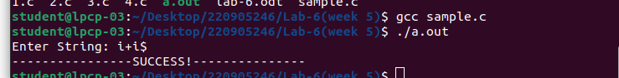

Write a recursive descent parser for the following simple grammars.

Q1) 1. S→a | > | ( T )
T→T, S|S

Code:

#include <stdio.h>
#include <stdlib.h>
#include <string.h>

char input[100];
int current = 0;

void S();
void T();

void error() {
printf("Syntax Error!\n");
exit(0);
}

void S() {
if (input[current] == 'a' || input[current] == '>') {
current++;
} else if (input[current] == '(') {
current++;
T();
if (input[current] == ')') {
current++;
} else {
error();
}
} else {
error();
}
}

void T() {
S();
if (input[current] == ',') {
current++;
S();
}
}

int main() {
printf("Enter a string: ");
scanf("%s", input);
S();
if (input[current] == '$') {
printf("Valid String!\n");
} else {
error();
}
return 0;
}

Output:

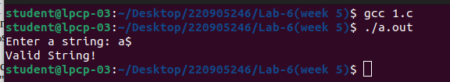

Q2) S→UVW
U →(S) | aSb | d
V → aV | €
W → cW | €

Code:

#include <stdio.h>
#include <stdlib.h>
#include <string.h>

char input[100];
int current = 0;

void S();
void U();
void V();
void W();

void error() {
printf("Syntax Error!\n");
exit(0);
}

void valid() {
printf("Valid String!\n");
exit(0);
}

void S() {
U();
V();
W();
}

void U() {
if (input[current] == '(') {
current++;
S();
if (input[current] == ')') {
current++;
} else {
error();
}
} else if (input[current] == 'a') {
current++;
S();
if (input[current] == 'b') {
current++;
} else {
error();
}
} else if (input[current] == 'd') {
current++;
} else {
error();
}
}

void V() {
if (input[current] == 'a') {
current++;
V();
}
}

void W() {
if (input[current] == 'c') {
current++;
W();
}
}

int main() {
printf("Enter a string: ");
scanf("%s", input);

S();

if (input[current] == '$') {
valid();
} else {
error();
}
}

Output:

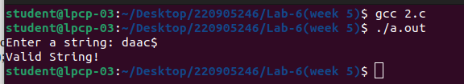

Q3)
S→aAcBe
A→Ab|b
B→d

Code:

#include <stdio.h>
#include <stdlib.h>
#include <string.h>

char input[100];
int current = 0;

void S();
void A();
void A_prime();
void B();

void error() {
printf("Syntax Error!\n");
exit(0);
}

void valid() {
printf("Valid String!\n");
exit(0);
}

void S() {
if (input[current] == 'a') {
current++;
A();
if (input[current] == 'c') {
current++;
B();
if (input[current] == 'e') {
current++;
} else {
error();
}
} else {
error();
}
} else {
error();
}
}

void A() {
if (input[current] == 'b') {
current++;
A_prime();
} else {
error();
}
}

void A_prime() {
if (input[current] == 'b') {
current++;
A_prime();
}
}

void B() {
if (input[current] == 'd') {
current++;
} else {
error();
}
}

int main() {
printf("Enter a string: ");
scanf("%s", input);

S();

if (input[current] == '$') {
valid();
} else {
error();
}
}

Output:

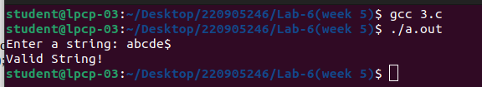

Q4)
S →(L) | a
L → L,S | S

Code:
#include <stdio.h>
#include <stdlib.h>
#include <string.h>

char input[100];
int current = 0;

void S();
void L();
void L_prime();

void error() {
printf("Syntax Error!\n");
exit(0);
}

void valid() {
printf("Valid String!\n");
exit(0);
}

void S() {
if (input[current] == '(') {
current++;
L();
if (input[current] == ')') {
current++;
} else {
error();
}
} else if (input[current] == 'a') {
current++;
} else {
error();
}
}

void L() {
S();
L_prime();
}

void L_prime() {
if (input[current] == ',') {
current++;
S();
L_prime();
}
}

int main() {
printf("Enter a string: ");
scanf("%s", input);

S();

if (input[current] == '$') {
valid();
} else {
error();
}
}

Output:

